SECTION B: Media Language and representation
Advertising and Marketing

H409 Media Studies: Paper 1, Section B

PAPER ONE OVERVIEW

Section B focuses on media language and representation and requires learners to consider how and why media language is used by media producers to create meaning and construct various representations of events, issues, individuals and social groups.
In this section, learners are required to study media forms and products set by OCR.

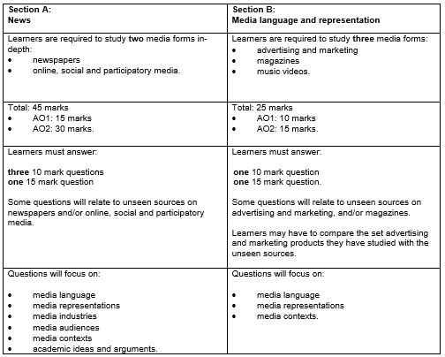

ASSESSMENT OBJECTIVES

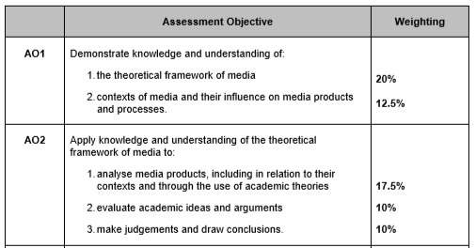
SET PRODUCTS

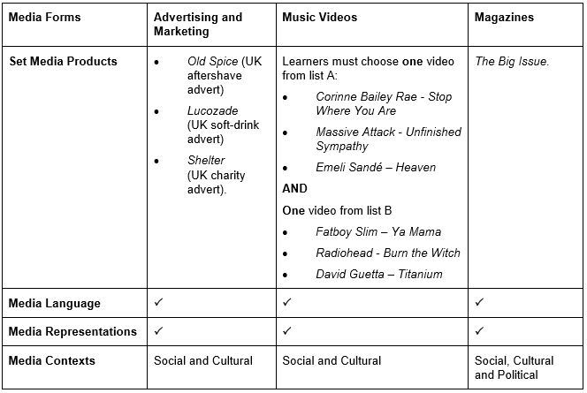

ADVERTISING AND MARKETING

In​ ​this​ ​unit of work,​ ​you​ ​will​ ​learn​ ​about​ ​advertising​ ​and​ ​marketing,​ ​ develop knowledge and understanding of media contexts, media language and representations through the study of advertising and marketing, magazines, and music video.

SET PRODUCTS

Advertising and marketing must be studied in relation to media language and media representations, including a consideration of the social and cultural contexts that influence how media language is used to construct representations.
Learners must study all three set advertising and marketing products in this section.
The media products will be made available by OCR. Three contrasting posters have been selected.
Learners need to study the set advertising and marketing products in relation to all the subject content bullet points listed under the ‘media language’ and ‘media representations’ topics in the subject content table following the end of component 02 to establish the codes and conventions of each category of advert.
Theories of media language and representation do not need to be studied
Consideration should be made of media language elements specific to advertising and marketing such as locations, costumes, props, makeup, lighting, choice of camera shot, angle, typography, layout and address of written content to the audience.

Old Spice ‘Smell Like a Man’ (2010)

The Old Spice ‘Smell Like A Man’ campaign poster from 2010 was a transformative mass market campaign for the aftershave brand. Prior to 2010 the Old Spice brand was associated with a much older, more mature male audience. This poster was part of a campaign that sought to reposition the brand and make it more accessible to younger audiences

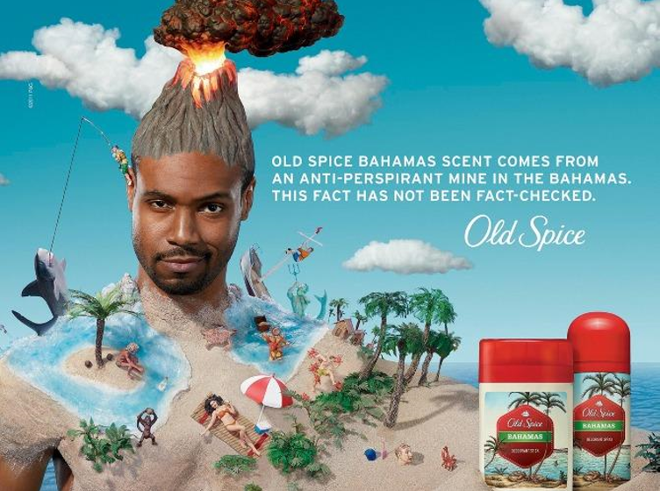

Shelter (2011)

Shelter, the UK-based housing and homelessness charity launched an advertising campaign in 2011 that was produced for those at risk of homelessness to point them to Shelter’s free services and guide them to seek advice on issues around homelessness earlier.

Lucozade ‘I believe’ (2013)

The Lucozade ‘I believe’ campaign poster from 2013 was part of a £4m mass market campaign to educate consumers about how the soft drink brand can help improve people’s sports performance, and features footballer Gareth Bale as a key brand ambassador.

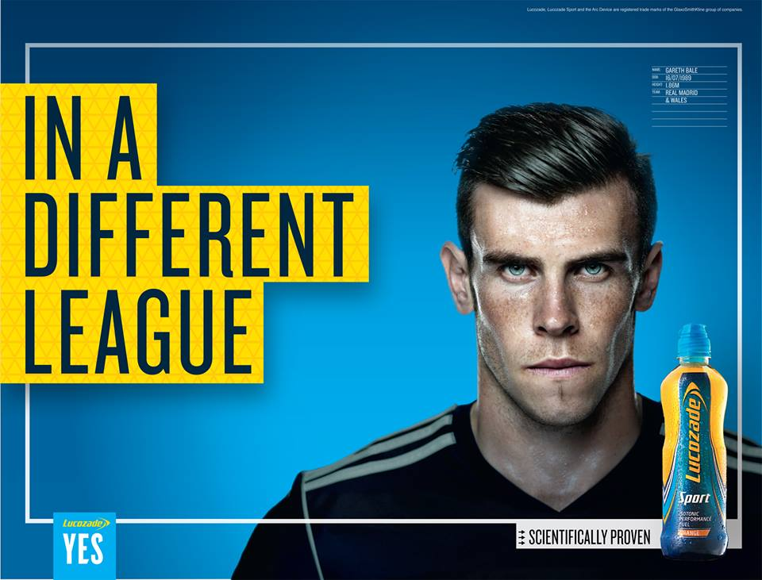

TASKS
You have created (or I did it for you!) a Google Slides presentation about each advert add each element below to complete your revision.
TASKS | COMPLETED?
- RESEARCH INSTITUTIONS / OWNERSHIP

For each of the three products, research the brand or charity behind it.

Provide information about the following, for each of the institutions:

Ownership: who owns the company or charity? How long has it been running for?
What is its worth?
What other products is it associated with?
What appear to be the ideologies or values of the company/charity?

- RESEARCH: Product CONTEXT

For each of the products, research the history of it.

- First launched?
- Target audience?
- Facts and figures – numbers / successes
- Brand identity – historically. Find visual examples of previous print adverts. Annotate representations.
- Social context – what was happening socially at the peak of the brand’s success? What about when the brand identify was at its lowest?
- Associated products / competitors
- Associated news stories (historically)
- Any notable rebranding

- The Campaign

For each of the products, find examples of the same marketing campaign in different formats (ie TV ad, online ad, digital ad, viral marketing etc)

Where was it advertised?
How? When? What type of magazine?
Where were the billboards placed? Between which television programmes? WHY?

Were the campaigns successful? Facts/figures if possible.

- The Products

For each of the products, annotate them with the following:

Typography: type and style of fonts/texts. How does it appeal to audience? How does it define the product?

Logo: Is there one? What is it? How does it promote the brand? How does it appeal to audience?

Further elements to analyse:
locations, costumes, props, makeup, lighting, choice of camera shot, angle, typography, layout and address of written content to the audience.

The questions to consider each element by are:
How does it promote the brand? How does it appeal to audience? What does the branding say abou the target audience?

- Representation

For each of the adverts:

Who or what is being represented?
How is the representation constructed?
Who has created the representation?
At whom is the representation targeted? How do you know?
What does the representation mean to them?
What does the representation mean to you?

Is it a positive or negative representation?
Does it challenge or subvert stereotypes?

- Intertextuality
What other films/music/tv/radio/adverts/literature does the advert remind you of?
How does it show similarities to other media products?
WHY?
How does this help the brand image?

SUBJECT CONTENT
CONTEXT | TASKS
how the media products studied differ in institutional backgrounds and use of media language to create meaning and construct representations to reach different audiences, and can act as a means of: - reflecting social, cultural and political attitudes towards wider issues and beliefs - constructing social, cultural and political attitudes towards wider issues and beliefs   how media products studied can act as a means of reflecting historical issues and events   how media products studied can potentially be an agent in facilitating social, cultural and political developments through the use of media language to construct meaning through viewpoints, messages and values and representations of events and issues   how media products studied are influenced by social, cultural, political and historical contexts through intertextual references   how media products studied reflect their economic contexts through production, financial and technological opportunities and constraints | 1 & 2
Language
how the different modes2 and language3 associated with different media forms communicate multiple meanings   how the combination of elements of media language influence meaning   how developing technologies affect media language  the codes and conventions of media forms and products, including the processes through which media language develops as genre   the dynamic and historically relative nature of genre   the processes through which meanings are established through intertextuality   how audiences respond to and interpret the above aspects of media language   how genre conventions are socially and historically relative, dynamic and can be used in a hybrid way   the significance of challenging and/or subverting genre conventions   the significance of the varieties of ways in which intertextuality can be used in the media   the way media language incorporates viewpoints and ideologies. | Tasks 4 & 5
Representation
How the media portray events, issues, individuals and social groups.   the way events, issues, individuals (including self-representation) and social groups (including social identity) are represented through processes of selection and combination   the way the media through representation constructs versions of reality   the processes which lead media producers to make choices about how to represent events, issues, individuals and social groups   the effect of social and cultural context on representations  how and why stereotypes can be used positively and negatively   how and why particular social groups, in a national and global context, may be under-represented or misrepresented   how media representations convey values, attitudes and beliefs about the world and how these may be systematically reinforced across a wide range of media representations   how audiences respond to and interpret media representations   the way in which representations make claims about realism   the impact of industry contexts on the choices media producers make about how to represent events, issues, individuals and social groups   the effect of historical context on representations   how representations may invoke discourses and ideologies and position4 audiences   how audience responses to and interpretations of media representations reflect social, cultural and historical circumstances. | Tasks 5 & 6

